COVID-19 - the global spread

Edward Beake

This report offers an overview of the global spread of COVID-19, using the lastest country level data from Johns Hopkin Centre for System Science and Engenering.

## Confirmed Cases

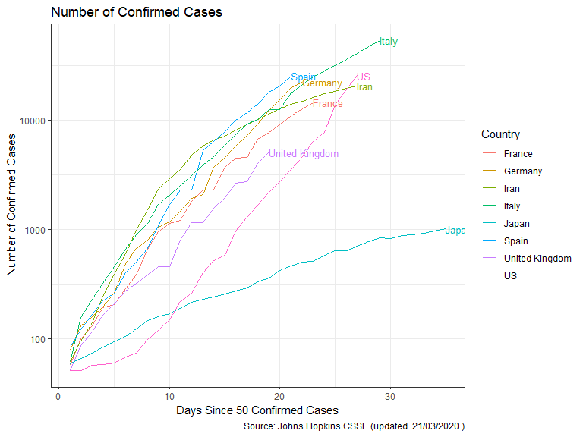

## Deaths

